SPECIALIST 3 &4 PRACTICE

SOLUTIONS
1. (a)
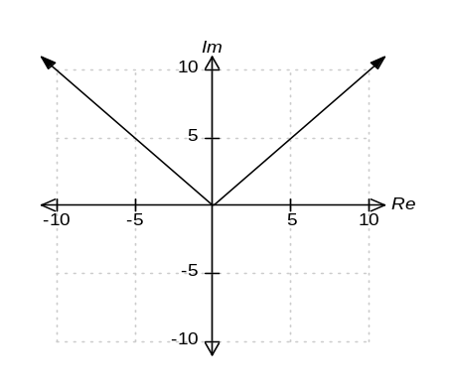
✓
✓
Let z = x + y i
Then Im(z) = y and Re(z) = x

Hence, Im(z) = ⏐Re(z)⏐ becomes
y = ⏐x⏐.

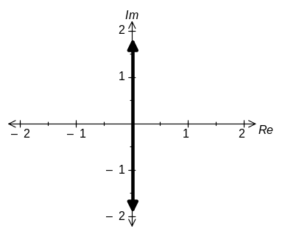 (b)
Let z = x + y i .
⇒ Im(z) = y
⏐z ⏐= √(x² + y²)
Hence Im(z) = ⏐z ⏐becomes
√(x² + y²) = y
⇒ x = 0
✓
✓
✓
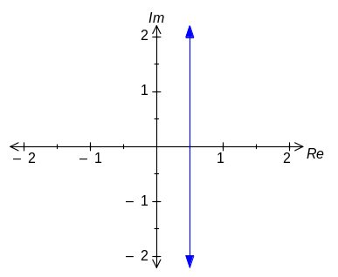 (c)
Let z = x + y i.
Then z + = 1 becomes
x + y i + (x − y i) = 1
⇒ 2x = 1
x = ½
[8]
✓
✓
✓

2. (a) z = 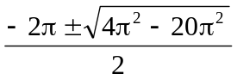 ✓
= − π ± 2πi ✓✓
(b) z³ = e³ cis(π + 2nπ) ✓
z = e cis(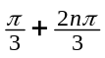) ✓
z = e (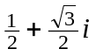) , −e , e (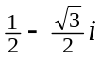) ✓✓
[7]
3. (a) {x : x > 0, x ≠ } ✓✓
(b) y ≠ 0 ✓✓
(c) Yes, as f is a one-to-one and onto function. ✓✓
(or the graph of y = f(x) passes the horizontal line test.)
Write x = 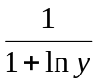 ✓
1 + ln y = 
y = e^{1/x−1} ✓
[8]

4. (10 marks)
The graph of 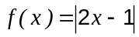 is shown below.
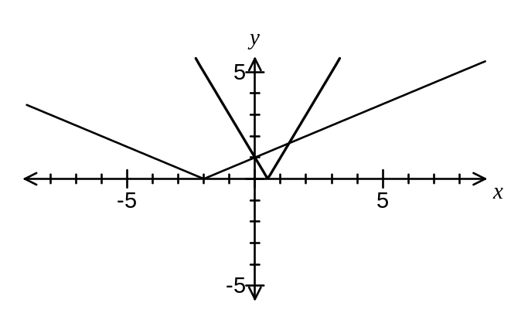
(a) Add the function 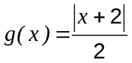 to the graph. (1 mark)

(b) Solve 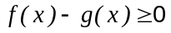. (3 marks)
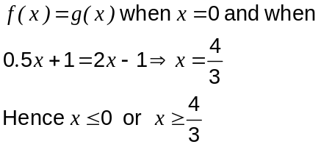

The graphs of 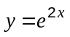 and 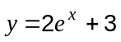 intersect at the point A, shown on the graph below.
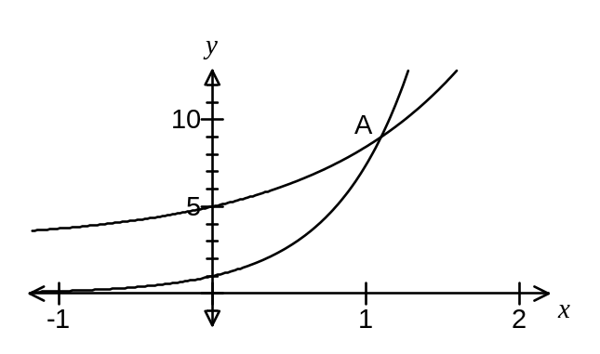
(c) Show that the -coordinate of A is 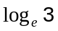. (3 marks)
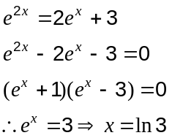

(d) Determine the exact area, in simplest form, of the region bounded by the two curves and the y-axis. (3 marks)
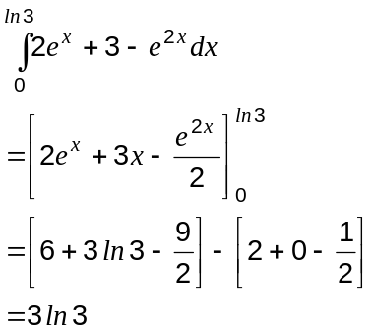

5.

Question 2 (7 marks)
Two complex numbers are given by 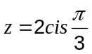 and 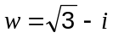.
(a) Determine 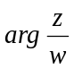 (2 marks)
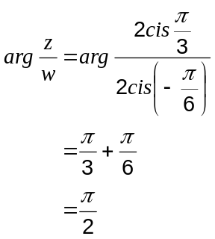

(b) Evaluate 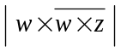. (3 marks)
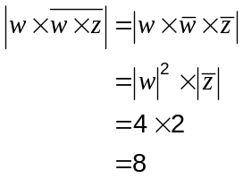

(c) Find the complex number given that 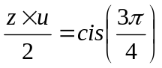. (2 marks)
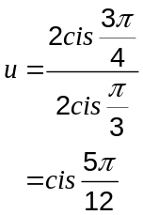

6. (a) I = 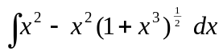 or 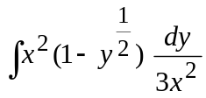 ✓
= 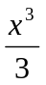 − 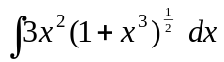 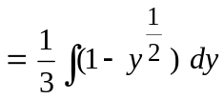 ✓
= − 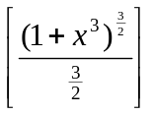 + C 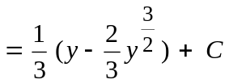 ✓
= − 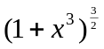 + C 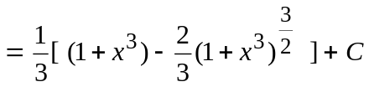 ✓

(b) I = 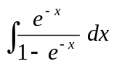 ✓
= ln⏐1 − e^{−x}⏐ + C ✓
(c) I = 
= sin x − i cos x + C ✓
= −i (cos x + i sin x) + C
= − i cis x + C ✓ [8]
7. (a)

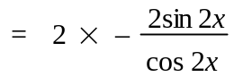 ✓
= − 4 tan 2x ✓

(b) Since,
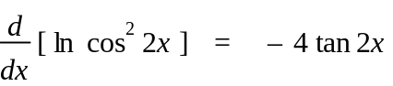
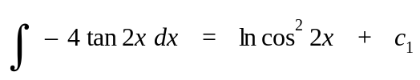 ✓
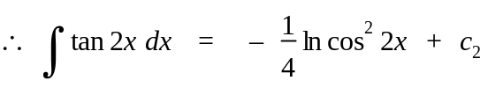 ✓ [4]

8. (a)
✓
✓
✓
(6 marks)
(a) Find the exact gradient of the curve 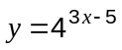 at the point (2, 4). (3 marks)
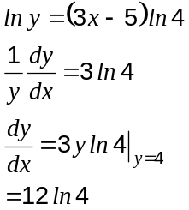

(b) Evaluate 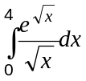. (3 marks)
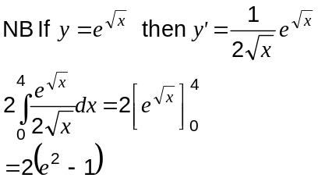

8. (a)
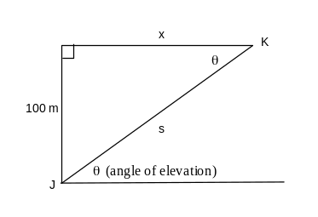
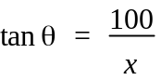 ✓
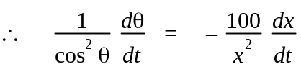 ✓
When t = 0, x = √(120² − 100²) = √4400 ✓
When t = 5, horizontal distance covered by kite = 10 × 5 = 50 m.
Hence, when t = 5, x = √4400 + 50 = 116.3325 m.
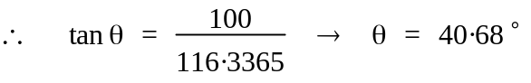 ✓
∴ when t = 5,
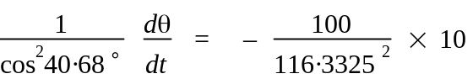
= −0.042 radians per second ✓

(b) s² = 100² + x² ✓
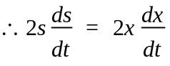 ✓
At t = 5, x = 116.3325, s = √(100² + 116.3325²) = 153.4055 : ✓
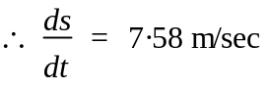 ✓ [9]
9. (a) (i)
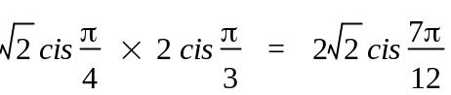 
(ii)
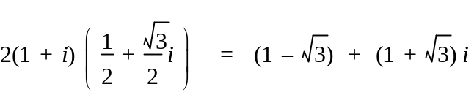 
(iii)
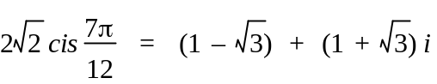 
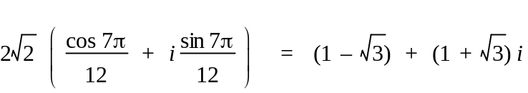
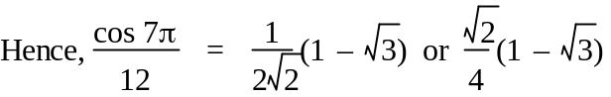 
. (b) (i) 2 + i and −2i. 

(ii) f(z) = k(z − 2i)(z + 2i)(z − 2 + i)(z − 2 − i) 
= k(z⁴ − 4z³ + 9z² − 16z + 20) 
f(1) = 20 ⇒ 20 = k(10)
Hence, k = 2 
f(z) = 2z⁴ − 8z³ + 18z² − 32z + 40
∴ a = 2, b = −8, c = 18, d = −32, e = 40 ✓ [13]

10. (a) At the y−axis y = − π ✓
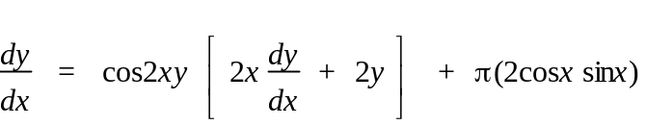 ✓✓
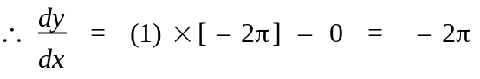 ✓
(b) If perpendicular 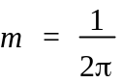 ✓
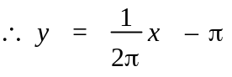 ✓ [6]
11.
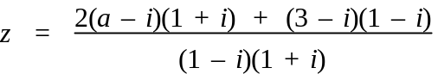 
= (a + 2) + (a − 3)i 
⎪z⎪ = 5 ⇒ (a + 2)² + (a − 3)² = 25 
a² − a − 6 = 0 
a = −2, 3  [7]

12. (a)
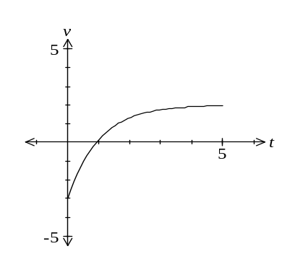


(b) Moves with constant velocity of 2 metres per second. 

(c) t = 0.91629 = 0.92 seconds (Use GC, root) 
(d) |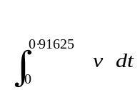| 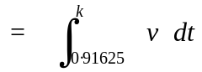 
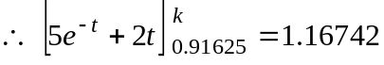 
1.16742 = 5e^{−k} + 2k − 3.83258 
k = 2.23 (use GC Solver) 
(e)
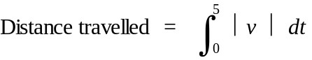 
= 7.3685 = 7.4 metres ✓ [11]

13. (a) x³ − 5x² + 6x = 0 
x(x − 2)(x − 3) = 0 
⇒ x = 0, 2, 3 

(b)
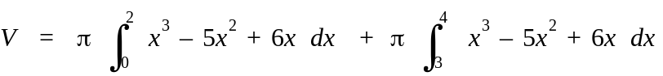 
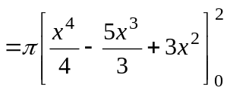 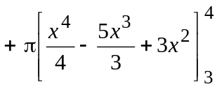 
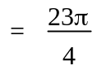  [7]
14.
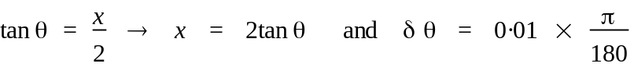 
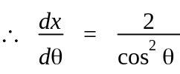 
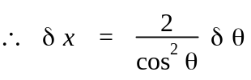 
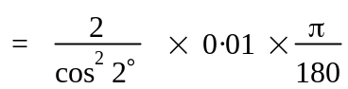 
= 3.4949 × 10⁻⁴ km
= 0.349 metres  [5]

.
15. A line and a plane are given by 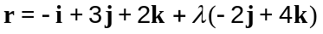 and .

(a) Find the position vector of the point of intersection of the line and plane. (2 marks)

Intersect when

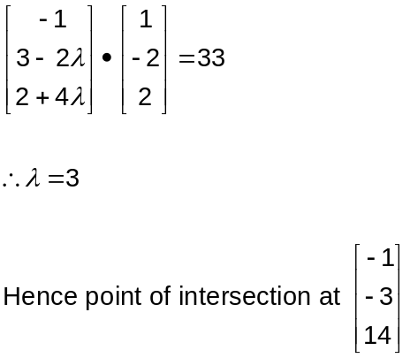

(b) Find the acute angle between the line and plane. (3 marks)
Find angle between line and normal to plane:

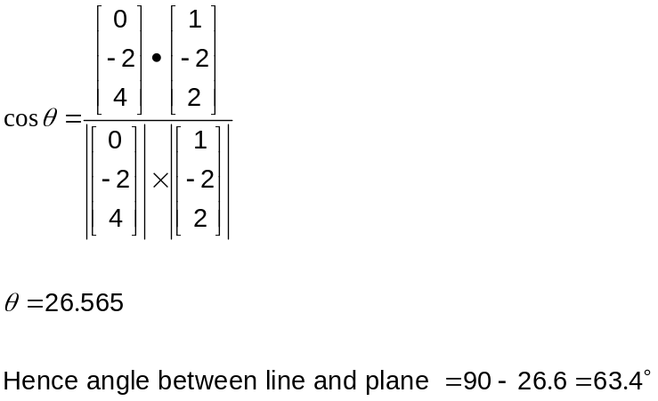

16.
(10 marks)
A body, A, has an initial position of 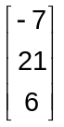 metres and is moving with a constant velocity of 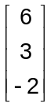 metres per second.

(a) A second body, B, is moving with constant velocity of 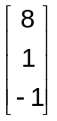 metres per second and collides with body A after six seconds.

Determine the initial distance apart of body A and body B. (4 marks)

A and B collide at
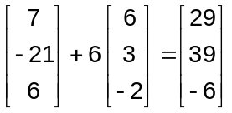

Hence initial position of B is at
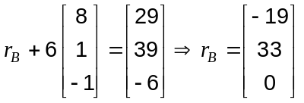

Distance apart of A and B is
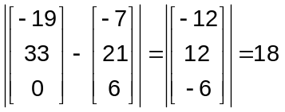

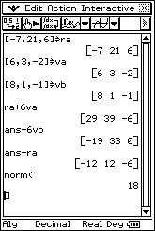

(b) A third body, C, is initially located at 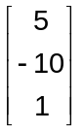 metres and is also moving with a constant velocity 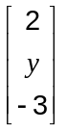. After five seconds, the distance between bodies A and C is a minimum.

Find the value of for which the speed of C is also a minimum. (6 marks)

Let and be velocity and displacement of A relative to C

Then minimum distance apart when and 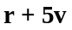 are perpendicular, ie the dot product of and is zero.

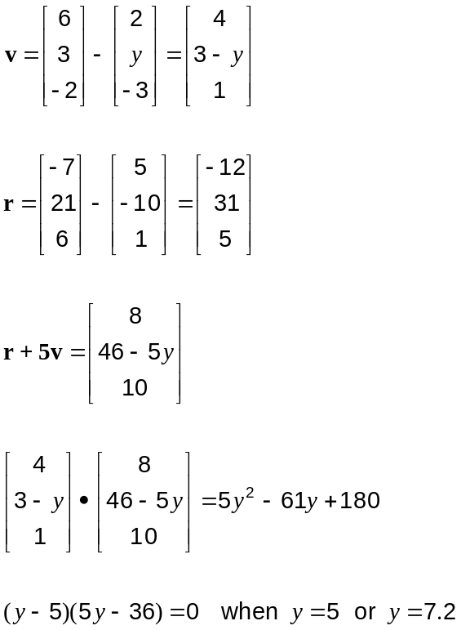

Hence for 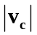 to be a minimum, 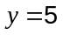.

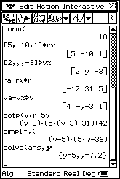

17. (a)
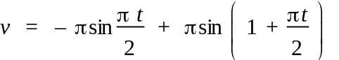 ✓
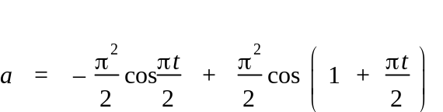
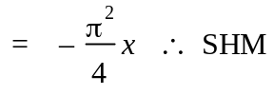 ✓
(b)
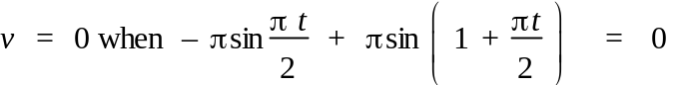
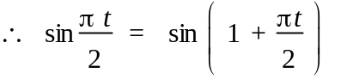 ✓ ∴ t = 0.68 ✓
(c) Maximum velocity = 3.01 ✓✓
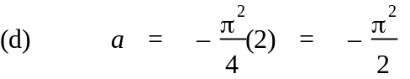 ✓✓ [8]

18. (a) 2(−0.5) + A = 0 → A = 1 ✓
1 − B = 0 → B = 1 ✓
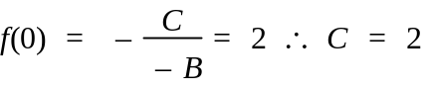 ✓
(b) Using GC
D(−0.90, −0.97), E(2.15, 0), F(−0.18, 1.80) ✓✓✓ [6]

19.
Question 14 (8 marks)
The temperature in a restaurant cool room is set to 4°C. One day, the refrigerator unit was turned back on after the temperature in the cool room had risen to 27°C due to cleaning and maintenance work. After 15 minutes, the temperature in the cool room had dropped to 11°C, with the temperature, , falling according to the model
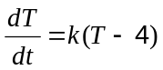
where is the time in minutes since the refrigerator unit was turned back on.

(a) Find the value of and express as a function of . (5 marks)
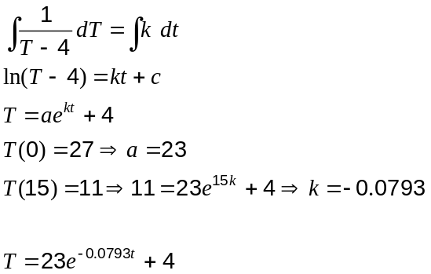

(b) If the temperature continues to fall in this way, how long before the temperature in the cool room registers 4°C, to the nearest degree? (3 marks)
Temperature must drop to 4.5°C

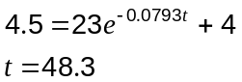

After 48.3 minutes.

